MATH 4371 FINAL EXAM (Spring 2008)
___
200

Name: SID:

The following is an assortment of True/False (the appropriate one to be circled) questions, technology comparisons (the appropriate letter to be circled), fill in the blank questions, computational questions, and LOGO exercises. Use either machine you wish, or neither machine as you see fit. Read each question very carefully, and for those that require written response, be as to the point as possible. By placing your name on this you affirm that this is your own work and you have not received help on this exam from anyone else (other than possibly the course instructor) and you will not discuss this exam with anyone who has yet to take it..

1. (21p)Compute the following integers:
gcd(16,18) =2
gcd(27²⁰ , 31¹²) = 1
lcm(650,450) = 5850
12 mod 8 = 4
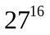mod 2 = 1
100 ! mod 5 = 0
What does it mean to say that p is the greatest common divisor of m and n?
What does it mean to say the p is the least common multiple of m and n?
P is the largest integer that divides evenly (is a factor of) both m and n.

What does it mean to say that r = m mod n?
P is the smallest integer that is divisible by both m and n.

R is the remainder when m is divided by n. That is, m = qn +r for some integer q and
0 < r < n.

2. (7p) Explain why any power of an odd integer must be an odd integer.
One way: If 2 is not a factor in the prime decomposition of an integer, then 2 is not a factor in any power of the integer because the primes factors in the power of an integer are powers of the same prime factors in the integer.

Second way: From the binomial theorem we see the expansion of any power of an odd integer has the form 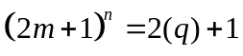for some integer q.

3. (4p) Convert the following numbers in Sci-Notation to the equivalent decimal.
2.9123 E-4 =0.00029123
6 p
2.9123 E6 =2912300
4. (4p) What are the integer fractions represented by the following decimal numbers.
1.914 = 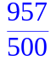
1.9141 = 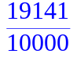

5. (10p) Demonstrate the Fundamental Theorem of Arithmetic.

6. (10p) Demonstrate the Binomial Theorem.
ifactor(10!)= 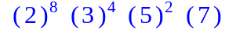

> expand((a+b)^5);
seq(binomial(5,j),j=0..5);
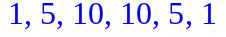

7. (2p) All rational numbers have an equivalent integer fraction representation. TRUE / FALSE

8. (2p) MAPLE can find the exact roots of all cubic polynomials. TRUE / FALSE

9. (2p) The calculator can find the exact roots of all quadratic polynomials. TRUE / FALSE

10. (10p) Indicate the correct letter, T for TI-86/83, M for MAPLE, or B for both, that best answers each of the following questions. Each question begins with the phrase:
Which technology . . .
a. . . . . uses floating point arithmetic only? T M B
b. . . . . uses both floating point and exact arithmetic? T M B
c. . . . . can find approximate roots of polynomials? T M B
d. . . . . can factor polynomials? T M B
e. . . . . sketches the graphs of functions of one variable? T M B
f. . . . . sketches the graphs of functions of two variables? T M B
g. . . . . can compute the gcd of any two integers? T M B
h. . . . . can do symbolic manipulation? T M B
i. . . . . allows multiple graphs on the same axis? T M B
j. . . . . is really cool? T M B

11. Let p = x³+2x²+x+2.
a. (5p) Find all the roots of p.
Solve returns that awful cubic root formula, fsolve(p,x) returns only the real root, fsolve(p,x,complex) returns all three roots.
> fsolve(p=0,x,complex);
b. (5p) Factor p into linear terms.
factor(p) does nothing. factor(p,complex) factors p
> factor(p,complex);
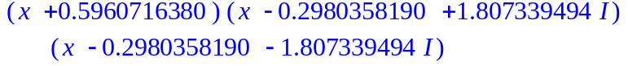
c. (2p) What is the y-intercept of the graph of p?
p(0) = 2

d. (2p)What are the x-intercepts of the graph of p?
x = 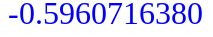
e. (5p) Insert the graph of p.

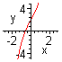

12. (5p) Find the polynomial x³+ax²+bx+c that has roots 1,2,3.

> expand((x-1)*(x-2)*(x-3));
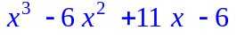

13. (2p) For any polynomial p(x) you can always find a number M so that the graph of p(x)+M crosses the x-axis. TRUE / FALSE

14. (2p) For any even degree polynomial p(x) and any number M the polynomial p(x)+M must have at lease one real root. TRUE / FALSE

15. (2p) For any odd degree polynomial p(x) you can always find a number M so that the polynomial p(x)+M has no real roots. TRUE / FALSE

16. (2p) Graphs of functions can not contain vertical lines. TRUE / FALSE

17. (10p) Insert a graph showing the effect of changing the parameter k on the graphs of (x+k)³ +1 .
> plot({seq((x+k)^3+1,k=-2..2)},x=-5..5,y=-10..10);
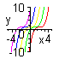

18. (5p) Find the equation of the line tangent to the graph of 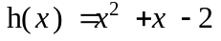 at the point where x=1.
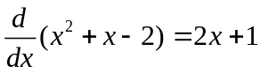 so the slope at x = 1 is 3. The equation is of the line through
(1 , 0) with slope 3 is given by y = 3(x-1).

(5p) Insert a graph showing the graph of h(x) and this tangent line on the same axes.
> plot({x^2+x-2,3*(x-1)},x=-2..2,y=-5..5);
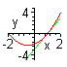
19. (9p) What does the derivative of a function tell you about the graph of the function?
20. (2p) If a function is positive at some point then its' derivative must also be positive at that point. TRUE / FALSE
The function is increasing every where the derivative is positive and the function is decreasing everywhere the derivative is negative.

21. (10p) Explain how we can estimate the area of a curved region like the one shaded here.
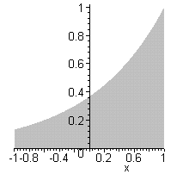
We can use rectangles with base on the x-axis and tops determined by the graph to approximate the curved area. The more rectangles we have the better the approximation will be.
22. (5p) Find the area between the graph of 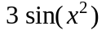 and the x-axis from 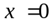 to 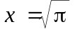 .
> evalf(int(3*sin(x^2),x=0..sqrt(Pi)));
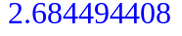
23. (5p) Insert a graph which demonstrates how boxes can be used to estimate the area in problem #22.
> with(student):
middlebox(3*sin(x^2),x=0..sqrt(Pi),10);
evalf(middlesum(3*sin(x^2),x=0..sqrt(Pi),10));
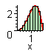
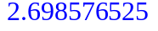

24. (25) Insert a picture labeled with your name with a star by it in the upper right corner, four stacked circles of radius 30 in the upper left corner, the first twenty regular polygons with side length 30 all drawn from the same starting point in the lower left corner, and a right triangle with base 100 and height 50 in the lower right corner. Also give yourself a nice star by your name.

25. (5p) Write a LOGO program which draws a right triangle with side lengths :a and :b in general position. (You can not use the HOME command or the setxy command.)
to righttriangle :a :b
fd :a rt 90 fd :b
rt 180-arctan :a/:b
fd sqrt ((power :a 2)+(power :b 2))
end

26. (15p) Insert the picture of your school house.



__
10

